Московский авиационный институт

(национальный исследовательский университет)

Институт № 8 «Информационные технологии и прикладная математика»

**Лабораторная работа №3**

**по курсу «Теоретическая механика»**

**Динамика системы**

Выполнил студент группы М8О-203Б-20

Сорокин Никита Эдуардович

Преподаватель: Беличенко Михаил Валериевич

Холостова Ольга Владимировна

Оценка:

Дата: 10.05.2022

Москва, 2022

**Вариант №«31»**

**Задание:**

Численно решить дифференциальные уравнения движения механической системы c помощью Python, сделать задание №12 курсовой и построить анимацию движения системы.

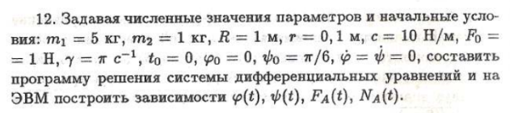

**Механическая система:**

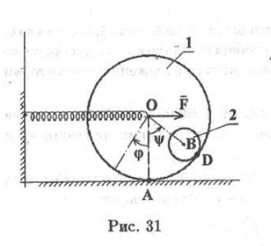

**Текст программы**

import numpy as npimport matplotlib.pyplot as pltfrom matplotlib.animation import FuncAnimationimport sympy as spfrom scipy.integrate import odeintpi = 4 * np.arctan(1)g = 9.81full_output = 1# y = (phi, psi, phi', psi')def odesys(y, t, m1, m2, R, r, c, F0, gamma, g): der_y = np.zeros(4) der_y[0] = y[2] # phi' = y[2] der_y[1] = y[3] # psi' = y[3] a11 = 2 * (m1 + m2) * R a12 = m2 * (R - r) * (1 + np.cos(y[1])) a21 = R * (1 + np.cos(y[1])) a22 = 2 * (R - r) * r b1 = (F0 * np.sin(gamma * t)) - (c * R * y[0]) + (m2 * (R - r) * y[3] * y[3] * np.sin(y[1])) b2 = - g * np.sin(y[1]) der_y[2] = (b1*a22 - b2*a12)/(a11*a22 - a12*a21) # phi'' находится по методу Крамера der_y[3] = (b2*a11 - b1*a21)/(a11*a22 - a12*a21) # psi'' находится по методу Крамера return der_y# Заданные числовые значения и начальные условия####################m1 = 5m2 = 0.5R = 1r = 0.1c = 10F0 = 1gamma = piphi0 = 0psi0 = pi / 6der_phi0 = 0der_psi0 = 0####################Steps = 1000t_fin = 20t = np.linspace(0, t_fin, Steps)y0 = [phi0, psi0, der_phi0, der_psi0]Y = odeint(odesys, y0, t, (m1, m2, R, r, c, F0, gamma, g))print(Y)# der - derivativephi = Y[:, 0]psi = -pi/2 + Y[:, 1]der_phi = Y[:, 2]der_psi = Y[:, 3]der2_phi = [odesys(y, t, m1, m2, R, r, c, F0, gamma, g)[2] for y,t in zip(Y,t)]der2_psi = [odesys(y, t, m1, m2, R, r, c, F0, gamma, g)[2] for y,t in zip(Y,t)]print(der2_phi[1])F_A = (m1 + m2)*R*der2_phi[1] + m2*(R - r)*(der2_psi*np.cos(psi) - der_psi*der_psi*np.sin(psi)) + c*R*phi - F0*np.sin(gamma*t)N_A = (m1 + m2)*g + m2*(R - r)*(der2_psi*np.sin(psi) - der_psi*der_psi*np.cos(psi))fig_for_graphs = plt.figure(figsize=[13,7])ax_for_graphs = fig_for_graphs.add_subplot(2, 2, 1)ax_for_graphs.plot(t, phi, color='blue')ax_for_graphs.set_title("phi(t)")ax_for_graphs.set(xlim=[0, t_fin])ax_for_graphs.grid(True)ax_for_graphs = fig_for_graphs.add_subplot(2,2,2)ax_for_graphs.plot(t,psi + pi/2,color='red')ax_for_graphs.set_title('psi(t)')ax_for_graphs.set(xlim=[0,t_fin])ax_for_graphs.grid(True)ax_for_graphs = fig_for_graphs.add_subplot(2,2,3)ax_for_graphs.plot(t,F_A,color='green')ax_for_graphs.set_title("F_A(t)")ax_for_graphs.set(xlim=[0,t_fin])ax_for_graphs.grid(True)ax_for_graphs = fig_for_graphs.add_subplot(2,2,4)ax_for_graphs.plot(t,N_A,color='black')ax_for_graphs.set_title('N_A(t)')ax_for_graphs.set(xlim=[0,t_fin])ax_for_graphs.grid(True)# Отсюда начинается лр2R1_array = np.full(Steps, R, dtype=int)r_0 = 2Point_O = R * phi + r_0theta = np.linspace(0, 2 * pi, 30)Circle1_X = R * np.cos(theta)Circle1_Y = R * np.sin(theta)Ground_X = [0, 0, 4]Ground_Y = [3, 0, 0]Line_OH_X = [0, 0]Line_OH_Y = [0, R]Point_A_X = Point_O + R * np.cos(- phi - pi / 2)Point_A_Y = R1_array + R * np.sin(- phi - pi / 2)Point_B_X = Point_O + (R - r) * np.cos(psi)Point_B_Y = R1_array + (R - r) * np.sin(psi)Circle2_X = r * np.cos(theta)Circle2_Y = r * np.sin(theta)AnglesCount = 20MaxWidth = 0.1Spring_X = np.zeros(AnglesCount)Spring_Y = np.zeros(AnglesCount)Spring_X[AnglesCount - 1] = 1k = AnglesCount - 2for i in range(AnglesCount - 2): Spring_X[i + 1] = (i + 1) / k - 1 / (2 * k) Spring_Y[i + 1] = ((-1) ** i) * MaxWidthSpring_Length = Point_OFigure = plt.figure(figsize=[15,8])ax = Figure.add_subplot(1, 1, 1)ax.axis("equal")Drawed_Ground = ax.plot(Ground_X, Ground_Y, color="black", linewidth=3)Drawed_Point_O = ax.plot(Point_O[0], R, marker="o")[0]Drawed_Point_H = ax.plot(Point_O[0], 0, marker="o")[0]Drawed_Point_A = ax.plot(Point_A_X[0], Point_A_Y[0], marker="o")[0]Drawed_Point_B = ax.plot(Point_B_X[0], Point_B_Y[0], marker="o")[0]Drawed_Circle1 = ax.plot(Point_O[0] + Circle1_X, R + Circle1_Y)[0]Drawed_Circle2 = ax.plot(Point_B_X[0] + Circle2_X, Point_B_Y[0] + Circle2_Y)[0]Drawed_Line_OH = ax.plot(Line_OH_X, Line_OH_Y)[0]Drawed_Line_OA = ax.plot([Point_O[0], Point_A_X[0]], [R1_array[0], Point_A_Y[0]])[0]Drawed_Line_OB = ax.plot([Point_O[0], Point_B_X[0]], [R1_array[0], Point_B_Y[0]])[0]Drawed_Spring = ax.plot(Spring_X * Spring_Length[0], Spring_Y + R)[0]def Movement(i) : Drawed_Point_O.set_data(Point_O[i], R) Drawed_Point_H.set_data(Point_O[i], 0) Drawed_Point_A.set_data(Point_A_X[i], Point_A_Y[i]) Drawed_Point_B.set_data(Point_B_X[i], Point_B_Y[i]) Drawed_Circle1.set_data(Point_O[i] + Circle1_X, R + Circle1_Y) Drawed_Circle2.set_data(Point_B_X[i] + Circle2_X, Point_B_Y[i] + Circle2_Y) Drawed_Line_OH.set_data(Line_OH_X + Point_O[i], Line_OH_Y) Drawed_Line_OA.set_data([Point_O[i], Point_A_X[i]], [R1_array[i], Point_A_Y[i]]) Drawed_Line_OB.set_data([Point_O[i], Point_B_X[i]], [R1_array[i], Point_B_Y[i]]) Drawed_Spring.set_data(Spring_X * Spring_Length[i], Spring_Y + R)Animation = FuncAnimation(Figure, Movement, frames=Steps, interval=10)plt.show()

**Результат работы:**

Тест 1. Набор данных похожий на набор из №12

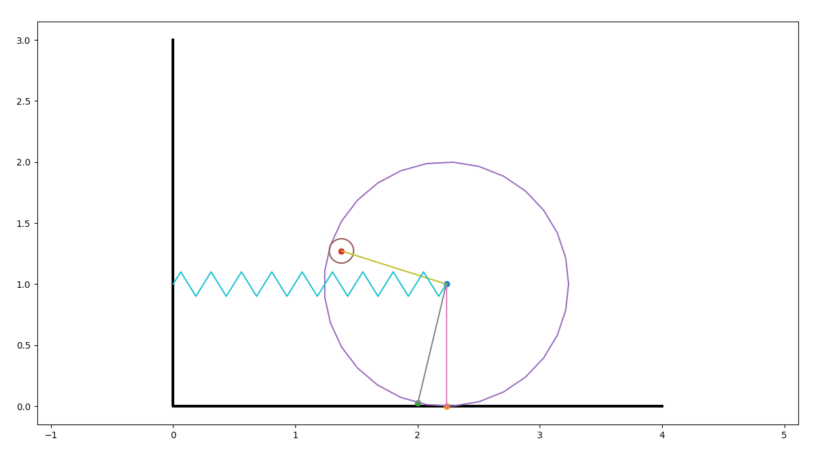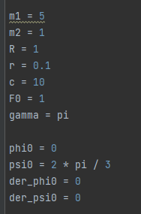

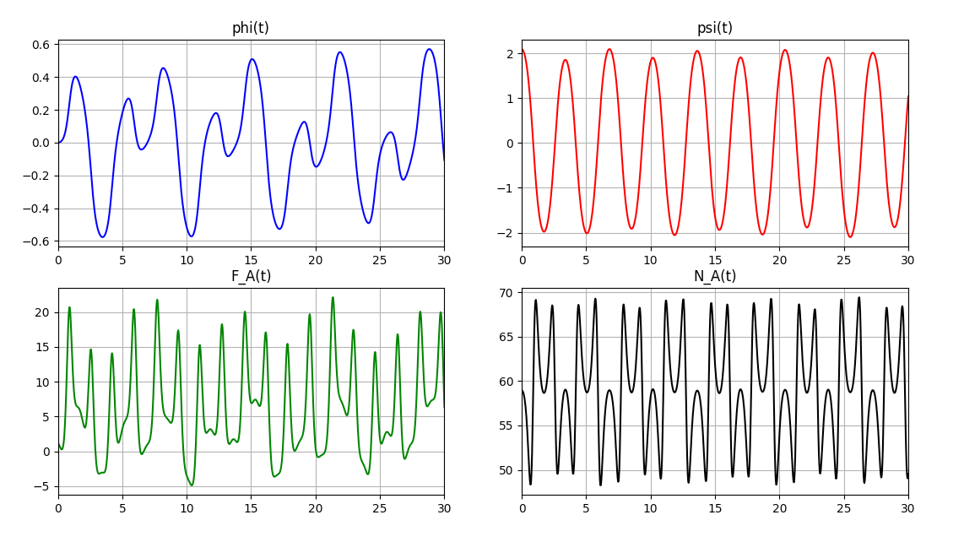

Тест 2. Положение неустойчивого равновесия

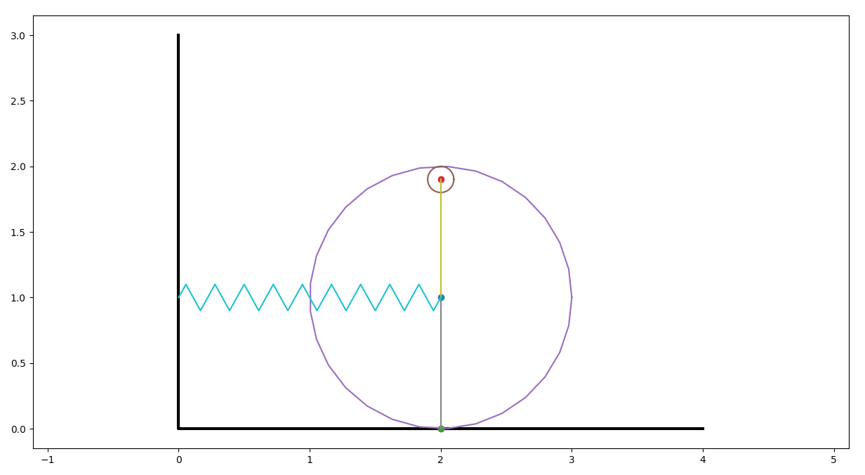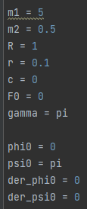

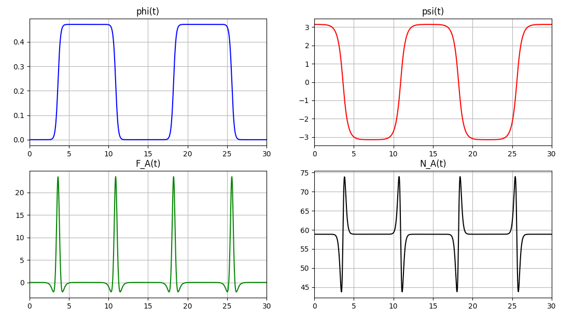

Тест 3. Сильная пружина

